Practical 1: Train and Test a Simple ML Model on the Same Dataset

Goal: Design and implement a simple machine learning classifier that is trained on a dataset and then evaluated ("tested") on that same dataset, in order to observe how a model fits the data it has seen.

Practical Explanation:
We use the classic Iris flower dataset (150 samples, 4 numeric features, 3 species classes). The workflow is:
- Save the dataset to a CSV file (to simulate a real-world "load from CSV" pipeline).
- Load the CSV with pandas.
- Split it into features (X) and target (y).
- Train a DecisionTreeClassifier.
- Predict on the same X used for training, and evaluate using accuracy, a confusion matrix, and a classification report.

Code:
"""
Task 1: Simple ML model - train and test on the SAME dataset Dataset: Iris (built-in, saved to CSV to mimic a real workflow) """
import pandas as pd
from sklearn.datasets import load_iris
from sklearn.tree import DecisionTreeClassifier
from sklearn.metrics import accuracy_score, confusion_matrix, classification_report

# Step 1: Create a CSV dataset (simulating a real-world CSV file) iris = load_iris(as_frame=True)
df = iris.frame df.to_csv("iris.csv", index=False)
print("Dataset saved as iris.csv with shape:", df.shape)

# Step 2: Load dataset from CSV data = pd.read_csv("iris.csv")
X = data.drop(columns=["target"]) # features y = data["target"] # labels

# Step 3: Train the model
model = DecisionTreeClassifier(random_state=42) model.fit(X, y)

# Step 4: Test on the SAME dataset (train == test, as required by the task)

y_pred = model.predict(X)

# Step 5: Evaluate
print("\nAccuracy on training data:", accuracy_score(y, y_pred)) print("\nConfusion Matrix:\n", confusion_matrix(y, y_pred)) print("\nClassification Report:\n",
classification_report(y, y_pred, target_names=iris.target_names

Output:
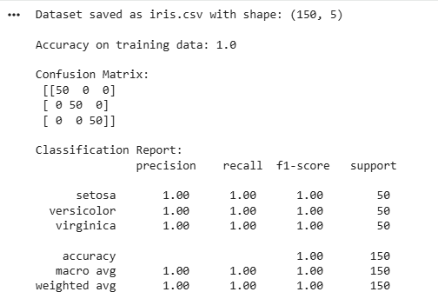

Explanation:
The decision tree perfectly memorizes the training data (100% accuracy), which is expected since it was tested on the exact data it learned from. This motivates the need for held-out test sets in real evaluation, which is a natural lead-in to discussing train/test splits or cross-validation.

Practical 2: FIND-S Algorithm

Goal:
Implement the FIND-S algorithm to find the most specific hypothesis that is consistent with all the positive training examples in a dataset loaded from a CSV file.

Practical Explanation:
FIND-S is a foundational concept-learning algorithm from machine learning theory (Mitchell, Machine Learning). It searches the hypothesis space from the most specific hypothesis toward more general ones, using only positive examples (negative examples are ignored).

Algorithm:
- Initialize the hypothesis h to the most specific hypothesis possible ('phi' for every attribute — meaning "no value satisfies this yet").
- For each positive training example:
  - For each attribute, if the hypothesis attribute is 'phi', set it to the example's value.
  - If it already has a value but differs from the example's value, generalize it to '?' (meaning "any value is acceptable").
- Negative examples are skipped entirely.
- Return the final hypothesis — the most specific one consistent with all positive examples.

We use the classic "EnjoySport" dataset (weather conditions → whether a sport was enjoyed).
Sample Dataset (enjoysport.csv) Sky,AirTemp,Humidity,Wind,Water,Forecast,EnjoySport Sunny,Warm,Normal,Strong,Warm,Same,Yes Sunny,Warm,High,Strong,Warm,Same,Yes Rainy,Cold,High,Strong,Warm,Change,No Sunny,Warm,High,Strong,Cool,Change,Yes

Code:
# Helper script to generate the sample CSV used in this practical import pandas as pd
data = {
"Sky": ["Sunny", "Sunny", "Rainy", "Sunny"],
"AirTemp": ["Warm", "Warm", "Cold", "Warm"],
"Humidity": ["Normal", "High", "High", "High"],
"Wind": ["Strong", "Strong", "Strong", "Strong"],
"Water": ["Warm", "Warm", "Warm", "Cool"],
"Forecast": ["Same", "Same", "Change", "Change"],
"EnjoySport": ["Yes", "Yes", "No", "Yes"]
}

pd.DataFrame(data).to_csv("enjoysport.csv", index=False)

"""
Task 2: FIND-S Algorithm
Finds the most specific hypothesis that fits all POSITIVE training examples.
"""
import pandas as pd

def find_s_algorithm(csv_path, target_col="EnjoySport", positive_label="Yes"):
data = pd.read_csv(csv_path)
attributes = data.columns[:-1] # all columns except the target print("Training data:\n", data, "\n")

# Step 1: Initialize hypothesis to the most specific one ('phi' for every attribute)
hypothesis = ['phi'] * len(attributes)

# Step 2: Iterate over each training example for i, row in data.iterrows():
if row[target_col] == positive_label: # consider only positive examples
for j, attr in enumerate(attributes):
if hypothesis[j] == 'phi': # first positive

example seen

hypothesis[j] = row[attr]
elif hypothesis[j] != row[attr]: # generalize

mismatched attribute
hypothesis[j] = '?'
print(f"After example {i+1} (positive): {hypothesis}") else:
print(f"After example {i+1} (negative): {hypothesis} (ignored
by FIND-S)")

return hypothesis

if name == " main ":
final_hypothesis = find_s_algorithm("enjoysport.csv") print("\nFinal Most Specific Hypothesis:", final_hypothesis)

Output:
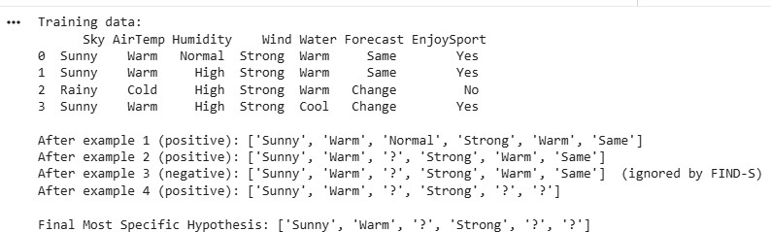

Explanation:
The final hypothesis says: "You enjoy the sport whenever Sky = Sunny, AirTemp = Warm, and Wind = Strong — regardless of Humidity, Water, or Forecast." This is the most specific generalization consistent with every positive example seen.

Practical 3: PCA-Based Feature Selection and Feature Scoring/Ranking

Goal: Load a dataset from a CSV file, apply Principal Component Analysis (PCA) for feature/dimensionality reduction, and separately perform feature scoring and ranking to identify which original features are most informative.

Practical Explanation:
This practical has two complementary parts:
- PCA (unsupervised, transforms features): Standardizes the numeric features, then projects them onto orthogonal principal components that capture the maximum variance. This is useful for dimensionality reduction and visualization, though the resulting components are combinations of the original features rather than the original features themselves.
- Feature scoring & ranking (supervised, keeps original features): Uses a statistical test (ANOVA F-test via SelectKBest) to score how strongly each original feature discriminates between classes, letting us rank and select the most relevant raw features.
We reuse iris.csv generated in Practical 1.

Code:
"""
Task 3: Load CSV -> Feature Selection via PCA -> Feature scoring & ranking Dataset: Iris (numeric features), reused from iris.csv (Task 1)
"""
import pandas as pd
from sklearn.preprocessing import StandardScaler from sklearn.decomposition import PCA
from sklearn.feature_selection import SelectKBest, f_classif

# Step 1: Load dataset from CSV data = pd.read_csv("iris.csv")
X = data.drop(columns=["target"]) y = data["target"]
feature_names = X.columns.tolist()

# Step 2: Standardize features (PCA is sensitive to feature scale) X_scaled = StandardScaler().fit_transform(X)

# Step 3: Apply PCA for dimensionality/feature reduction
pca = PCA(n_components=2) # reduce to top 2 principal components X_pca = pca.fit_transform(X_scaled)

print("Explained variance ratio per component:", pca.explained_variance_ratio_)
print("Total variance retained:", sum(pca.explained_variance_ratio_).round(4))

# Show how much each ORIGINAL feature contributes to each principal component
loadings = pd.DataFrame( pca.components_.T,
columns=[f"PC{i+1}" for i in range(pca.n_components_)], index=feature_names
)
print("\nPCA Component Loadings:\n", loadings)

# Step 4: Feature scoring & ranking using ANOVA F-test (independent of PCA)
selector = SelectKBest(score_func=f_classif, k="all") selector.fit(X, y)

scores_df = pd.DataFrame({ "Feature": feature_names,
"F-Score": selector.scores_, "p-value": selector.pvalues_
}).sort_values(by="F-Score", ascending=False).reset_index(drop=True) print("\nFeature Ranking (by ANOVA F-score):\n", scores_df)
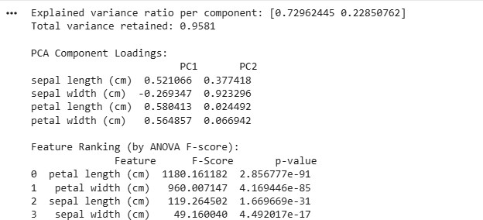
Output:

Explanation:
The first 2 principal components retain about 96% of the total variance in the data, showing that Iris can be reasonably represented in 2 dimensions instead of 4.
Independently, the F-score ranking shows petal length and petal width are by far the most discriminative original features for classifying species — which matches well-known domain knowledge about the Iris dataset

Practical 4: Candidate-Elimination Algorithm

Goal: Implement the Candidate-Elimination algorithm to compute the full version space
- the set of all hypotheses consistent with a set of training examples loaded from a CSV file — and output a description of the specific (S) and general (G) boundaries that describe it.

Practical Explanation:
Candidate-Elimination improves on FIND-S by using both positive and negative examples to maintain two boundary sets that together represent every hypothesis consistent with the data:
  - S (Specific boundary): the most specific hypotheses consistent with the data so far.
  - G (General boundary): the most general hypotheses consistent with the data so far.
Algorithm outline, for each training example:
- If positive:
  - Remove any hypothesis from G that is inconsistent with (does not cover) the example.
  - Generalize S minimally so it covers the example (same rule as FIND-S).
- If negative:
  - Remove any hypothesis from S that incorrectly covers the example.
  - Specialize each hypothesis in G that incorrectly matches the negative example, only along attributes where the specialization is consistent with S and successfully excludes the negative example. Discard specializations not supported by S.
We reuse the same enjoysport.csv from Practical 2.

Code:
"""
Task 4: Candidate-Elimination Algorithm
Maintains version space: Specific boundary (S) and General boundary (G) """
import pandas as pd

def candidate_elimination(csv_path, target_col="EnjoySport", positive_label="Yes"):
data = pd.read_csv(csv_path) attributes = data.columns[:-1] n = len(attributes)

# Step 1: Initialize S (most specific) and G (most general) boundaries S = ['phi'] * n # no example generalizes S yet
G = [['?'] * n] # single, fully general hypothesis

def consistent(hyp, row):
"""Check whether a hypothesis is consistent with (matches) a given
row."""
return all(h == '?' or h == row[attributes[i]] for i, h in
enumerate(hyp))

for idx, row in data.iterrows(): instance = row[attributes].tolist() label = row[target_col]

example
if label == positive_label:
# Remove from G any hypothesis inconsistent with the positive G = [g for g in G if consistent(g, row)]
# Generalize S minimally to cover the new positive example for i in range(n):
if S[i] == 'phi': S[i] = instance[i]
elif S[i] != instance[i]: S[i] = '?'

else:
# Specialize each general hypothesis in G that wrongly matches the negative example
new_G = [] for g in G:
if consistent(g, row):
# This general hypothesis incorrectly covers a negative example -> specialize it
for i in range(n):
# Only specialize on an attribute if doing so

actually differ attribute)
S[i] != instance[i]:

# excludes the negative example (S's value must # from the negative example's value at that
if g[i] == '?' and S[i] not in ('?', 'phi') and

specialized = g.copy() specialized[i] = S[i] new_G.append(specialized)

else:
new_G.append(g) # already consistent, keep as is G = new_G

print(f"\nAfter example {idx+1} ({label}):") print(" S =", S)
print(" G =", G) return S, G
if name == " main ":
S_final, G_final = candidate_elimination("enjoysport.csv") print("\n=== Final Version Space ===")
print("Specific boundary S:", S_final) print("General boundary G:", G_final)

Output:
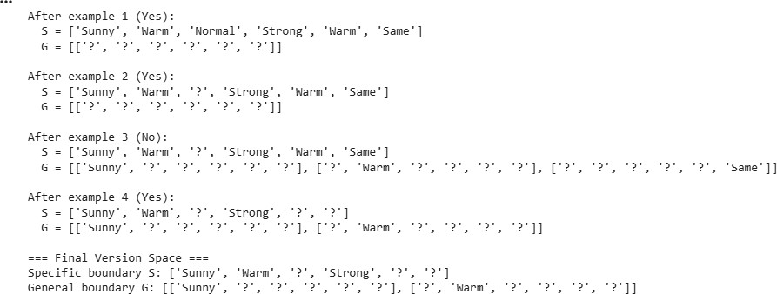

Explanation: The final version space is bounded by:

- S = [Sunny, Warm, ?, Strong, ?, ?] — the most specific hypothesis consistent with all examples.
- G = {[Sunny, ?, ?, ?, ?, ?], [?, Warm, ?, ?, ?, ?]} — the two most general hypotheses consistent with all examples.

Every hypothesis that is more general than S and more specific than some member of G (e.g., [Sunny, Warm, ?, ?, ?, ?]) is also a valid, data-consistent hypothesis — together S and G compactly describe this entire space without enumerating every member individually. This result matches the well-known outcome for the classic EnjoySport dataset from Mitchell's Machine Learning textbook.

